A: GENERAL INFORMATION:

Mandatory Disclosure
APPENDIX-IX

SL NO. | INFORMATION | DETAILS
1 | NAME OF THE SCHOOL | Alliance International School
2 | AFFILIATION NO. (IF APPLICABLE) | 1631039
3 | SCHOOL CODE (IF APPLICABLE) | 21046
4 | COMPLETE ADDRESS WITH PIN CODE | Chd-Patiala National Highway, Sec-8, Ram Nagar Near Banur, Rajpura, District Patiala-140601 (Punjab)
5 | PRINCIPAL NAME | Mr.BRIJESH SAXENA
6 | PRINCIPAL QUALIFICATION | M.A., M.Ed.
7 | SCHOOLE MAIL ID | allianceinternationalskool@gmail.com
8 | CONTACT DETAILS (LANDLINE/MOBILE) | 7837991000
B: DOCUMENTS AND INFORMATION:
SL NO. | DOCUMENTS/INFORMATION | UPLOADED/ATTACHED DOCUMENTS
1 | COPIES OF AFFILIATION/UPGRADATION LETTER AND RECENT EXTENSION OF AFFILIATION, IF ANY | Attached here with, please scroll down
2 | COPIES OF SOCIETIES/TRUST/COMPANY REGISTRATION/RENEWAL CERTIFICATE, AS APPLICABLE | Attached here with, please scroll down
3 | COPY OF NO OBJECTION CERTIFICATE (NOC) ISSUED, IF APPLICABLE, BY THE STATE GOVT./UT | Attached here with, please scroll down
4 | COPIES OF RECOGNITION CERTIFICATE UNDER RTE ACT, 2009, AND IT’S RENEWAL IF APPLICABLE | Attached here with, please scroll down
5 | COPY OF VALID BUILDING SAFETY CERTIFICATE AS PER THE NATIONAL BUILDING CODE | Attached here with, please scroll down
6 | COPY OF VALID FIRE SAFETY CERTIFICATE ISSUED BY THE COMPETENT AUTHORITY | Attached here with, please scroll down
7 | COPY OF THE DEO CERTIFICATE SUBMITTED BY THE SCHOOL FOR AFFILIATION/UPGRADATION/EXTENSION OF AFFILIATIONOR SELF CERTIFICATION BY SCHOOL | Attached here with, please scroll down
8 | COPIES OF VALID WATER, HEALTH AND SANITATION CERTIFICATES | Attached here with, please scroll down
NOTE : THE SCHOOLS NEEDS TO UPLOAD THE SELF ATTESTED COPIES OF ABOVE LISTED DOCUMENTS BY CHAIRMAN/ MANAGER /SECRETARY & PRINCIPAL. IN CASE, IT IS NOTICED AT LATERST AGE THAT UPLOADED DOCUMENTS ARE NOTGENUINE THEN SCHOOL SHALL BE LIABLE FOR ACTION AS PER NORMS.

C: RESULT AND ACADEMICS:

S.NO. | DOCUMENTS/ INFORMATION | LINKS OF UPLOADED DOCUMENTS ON SCHOOL'S WEBSITE
1 | FEE STRUCTURE OF THE SCHOOL | Attached here with, please  Scroll down
2 | ANNUAL ACADEMIC CALANDER. | Attached here with, please  Scroll down
3 | LIST OF SCHOOL MANAGEMENT COMMITTEE (SMC) | Attached here with, please  Scroll down
4 | LIST OF PARENTS TEACHERS ASSOCIATION (PTA) MEMBERS | Attached here with, please  Scroll down
5 | LAST THREE-YEAR RESULT OF THE BOARD EXAMINATION AS PER APPLICABLILITY | Annexed here under

RESULT CLASS : X -

S.NO. | YEAR | NO.OF REGISTERED STUDENTS | NO. OF STUDETNS PASSED | PASS PERCENTAGE | REMARKS
1 | 2024 | 50 | 50 | 100% | EXCELLENT
2 | 2023 | 36 | 36 | 100% | EXCELLENT
3 | 2022 | 33 | 33 | 100% | EXCELLENT
4 | 2021 | 31 | 31 | 100% | EXCELLENT
RESULT CLASS : XII -

S.NO. | YEAR | NO. OF REGISTERED STUDENTS | NO. OF STUDETNS PASSED | PASS PERCENTAGE | REMARKS
1 | 2024 | 89 | 79 | 89% | GOOD
2 | 2023 | 64 | 60 | 93.75% | GOOD
3 | 2022 | 17 | 16 | 94% | GOOD
4 | 2021 | -- | -- | -- | --

D: STAFF (TEACHING)

S. NO. | INFORMATION | DETAILS
1 | PRINCIPAL | Mr. BRIJESH SAXENA
2 | TOTAL NO. OF TEACHERS | 51
2 | - PGT | 20
2 | - TGT | 14
2 | - PRT | 17
3 | TEACHERS SECTION RATIO | 1.5
4 | DETAILS OF SPECIAL EDUCATOR | 1 on regular basis
5 | DETAILS OF COUNSELLOR AND WELNESS TEACHER | 1 on regular basis
E: SCHOOLINFRASTRUCTURE:

S.NO. | INFORMATION | DETAILS
1 | TOTAL CAMPUS AREA OF THE SCHOOL (IN SQUARE MTR) | 18144 Square Meters
2 | NO. AND SIZE OF THE CLASS ROOMS (IN SQ FT MTR) | Class Rooms–28 (55.74Sq.M.)
3 | NO. AND SIZE OF LABORATORIES INCLUDING COMPUTER LABS (IN SQ MTR) | Science Labs–4 (55.74 Sq. M.) Library – 1 (160.53 Sq. M.)  ComputerLab–1 (61.31Sq.M.)  MathsLab-1 (55.74Sq.M.)
4 | INTERNET FACILITY (Y/N) | Yes
5 | NO.OF GIRLS TOILETS | 15
6 | NO.OF BOYS TOILETS | 15
7 | LINK OF YOU TUBE VIDEO OF THE INSPECTION OF SCHOOL COVERING THE INFRASTRUCTURE OF THE SCHOOL | https://www.youtube.com/watch?v=UkwIoCICcvo


COPY OF AFFILIATION UPGRADATION LETTER W.E.F. 01.04.2020 TO 31.03.2023

Central Board of Secondary Education


Grant with Condition Letter for-:SS-01350-1920
NO . CBSE/AFF/1631039/SS-01350-1920/2019-20 18/08/2020
The Manager,
Alliance International School
Chd-Patiala national high way, Sec-8, Ram Nagar Near Banur, Rajpura PUNJAB , PATIALA-140601
(M: 01762-507888)
Subject : General Affiliation up to Senior Secondary Level- regarding. Ref : Application No. SS-01350-1920 dated 27.06.2018.
With reference to your application on the subject cited above ; I am directed to convey the sanction for General Affiliation as per details given below :
Affiliation No. |  |  | 1631039
Affiliated for |  |  | Senior Secondary School Examination
Category |  |  | Up gradation of Affiliation
Period of General affiliation |  |  | 01.04.2020 to 31.03.2023
Year and Month From which admission can be taken in Class-XI |  |  | 1April, 2020
Year and Month in which first batch of Class-XII will appear in Board Examinations |  |  | March, 2022
SUBJECTSALLOWED:
Languages |  | English Core, Hindi Elective
Elective Subjects |  | Physics, Chemistry, Mathematics, Biology, Accountancy, Business Studies, Political Science, Economics, Sociology, Physical Education, History, Legal Studies, Music Instrumental, Music Vocal
The facilities reported at the time of last inspection:
S. No. | Detail | No s | Size
1 | Area of school campus | -- | 18144 Sq.mtr.
2 | Built up area | -- | 5731 Sq.mtr.
3 | Area of play ground | -- | 8500 Sq.mtr.
4 | Composite Science Lab | 1 | 30x20Sq.ft.
5 | Mathematics Lab | 1 | 600 Sq. ft.

6 | Computer Lab | 1 | 30x22Sq.ft.
7 | Biology Lab | 1 | 30x20Sq.ft.
8 | Chemistry Lab | 1 | 30x20Sq.ft.
9 | Physics Lab | 1 | 30x20Sq.ft.
10 | Library rooms | 1 | 30.7x56.3Sq.ft.
11 | Classrooms | 25 | 30x20Sq.ft.
12 | Classrooms | -- | --
13 | Name of society running the school | Shri Raghu Nath Rai Memorial Educational & Charitable Trust
The above sanction is subject to fulfillment of following conditions:-
- The school will follow the syllabus on the basis of curriculum prescribed by NCERT/CBSE for the Middle Classes. The school will follow syllabus and courses as per scheme of studies prescribed by the Board for Secondary/Sr. Secondary School Examination and changes made therein from time to time.
- TheschoolshouldgothroughtheprovisionofAffiliationandExaminationByeLawsandkeepacopythere of for reference purpose and also advised to visit CBSE websites / , http://cbseacademic.nic.in/&http://cbse.nic.in/forupdates.TheSchoolisexpectedto see all circulars on these CBSE websites at least once every week.
- The school shall submit their information through Online Affiliated School Information System (OASIS) as per details given in circular no. affiliation-06/2018 dated 24.04.2018. Link for OASIS is available on Board’s website: www.cbse.nic.in.
- The school will follow the RTE Act, 2009 and instructions issued there on by the CBSE/Respective State
/UT Govt. from time to time.
- The school will enroll students proportionate to the facilities available in the school as prescribed in the Affiliation Bye-Laws of the Board which shall not in general exceed the optimum number as under:-

Campus area Enrolment No. of Sections(pre-primary No. of Sections at Sr. Secondary (XI
To X) & XII)
  - 1.0acre 1250 02 in each class 04 each in class XI and XII
  - 1.5acre 1875 03 in each class 04 each in class XI and XII
  - 2.0acre 2500 04 in each class 04 each in class XI and XII
  - School running on bigger campus of more than 02 acres, the number of students shall be restricted as per the actual facilities in the school which shall be proportionate to the optimum number mentioned at (a), (b) and(c) above.
- The school will provide well equipped Laboratories, Library and other facilities as per norms of the Board. The relevant books as per the academic level of students shall be made available in the library.
- The School should have at least one adequately equipped computer lab with a minimum of 10 computers and would ensure computer student ratio of 1:20 at least. Proper software along with facility of Broad Band connectivity with the feature of‘ internet always on’ from any service provider to be ensured.
- The schools affiliated and running up to Senior Secondary Level will provide suitable facilities including the equipment in laboratories/workshops and games for classes XI and XII as per requirements laid down in rules.
- The school will also abide by the conditions of Recognition/NOC prescribed by the State Government concerned.
- Theschoolisrequiredtorestrictthenumberofsectionsaspertheinfrastructurefacilitiesavailableintheschool as per rule 10.6ofAffiliationBye-laws. The optimum number of students in a section of a class should not be more than 40 and number of students at middle, secondary and senior secondary level of the school shall preferably be proportionate to each other.

- The section teacher ratio of 1:1.5 is to be maintained to teach various subjects and school shall appoint qualified and trained teaching staff on regular basis as per provisions of Affiliation Bye Laws of the Board
- The school and its records shall be open for inspection by an officer/official of the Board or an authorized representative of the Board/State Educational Department at any time and the school shall furnish information as may be asked for by the Board/State Government from time to time.
- As per Rule 13.3 and 13.3 (i), the school shall supply information and returns called for by the Board/State/ Central Government/Local Authority within the prescribed time given for its furnishing to the authority concerned and the school should prepare its annual report containing comprehensive information including name, address post a land e-mail, telephone numbers, affiliation status, period of General affiliation, details of infrastructures, details of teachers, number of students and status of fulfillment of norms of affiliation Bye- Laws and upload same on the school's website before 15th September of every year.
- The accounts should be audited and certified by a Chartered Accountant and proper accounts statements should be prepared in the name of school, as per rules.
- The school will strictly adhere with all rules regarding safety of students including Fire fighting and Transportation, etc. Further, school will provide adequate facilities for potable drinking water and clean healthy and hygienic toilets with washing facilities for boys and girls separately in proportion to the number of students.
- Teachers are to be educated to avoid Corporal Punishment i.e .rule no.44.1(d & e).
- As per rule no.8.2 and13.11,facilities for physically challenged student(s) should be adequately provided and every school shall promote inclusion of student(s) with disabilities/special needs in the normal school as per provisions of the ‘Rights of Persons with Disabilities Act 2016’.
- The school shall take care of Health, sanitation and fire safety requirements in accordance with rule no. 3.3 (vii), rule 8.5 and rule 23.11.
- The school has to constitute a committee for protection of woman from sexual harassment at the work place and to abide by the guidelines and norms prescribed by the Hon’ble Supreme Court of India in W.P. Criminal No.666-70 of 1992 Vishaskha and other vs State of Rajasthan and other delivered on13.8.1997 Refer rule no.10.9.
- Fees should normally be charged under the heads prescribed by the Department of Education of the State/U.T. for schools of different categories. No capitation fee or voluntary donations for gaining admission in the school or for any other purpose should be charged /collected in the name of the school and the school should not subject the child or his or her parents or guardians to any screening procedure inaccordance with Rule No. 11.1, 2 &3. Also, as per Chapter II, Rule No. 11.1 of Affiliation Bye-Laws, fees charged should be commensurate with the facilities provided by the institution.
- Theschoolshouldnotusethefacilitiesavailableforcommercialization:-
(a) | As per rule no.19.1(ii) It shall be ensured that the school is run as a community service and not as a business and that commercialization does not take place in the school in any shape whatsoever.
(b) | As per rule no. 19.1 (ii)(a) Any franchisee school making payment on account of use of name, motto and logo of franchiser institution or any other non-academic activities would be termed as commercialization of institution and the school is required to provide an affidavit that the school/society has not entered into any such contract to use Name, logo, motto for consideration of fee.

- Admission to the school is to be restricted as per rule 6.1 of Examination Bye-laws and rule12 (i, ii& iii)of Affiliation bye laws.
- School will not prepare any student/start class for any other Board except CBSE from their CBSE affiliated school building/ premises
- As per rule13.12(ii), no affiliated school shall endeavour to present the candidates who are not on its roll nor shall it present the candidate so fit sun affiliated Branch/School to any of the Board’s Examinations.
- Running of classes of coaching institutions in the school premises in the pretext of providing coaching to the students for various examinations is not approved by the board. Strict action would be taken on defaulters.

- Each school affiliated/to be affiliated with the Board shall frame Service Rules for its employees which will be as per Education Act of the state/U.T., if the Act makes adoption of the same obligatory, otherwise as per Service Rules given in Affiliation Bye Laws. Further, Service Contract will be entered with each employee as per the provisions in the Education Act of the state/ U.T., or as given in Appendix III.
- Pay and allowances to staff should be revised from time to time to bring it at par with that of State Government.
Further, Salary and service conditions of staff should be fixed in accordance with rule no.3.3
(v)and rule no.10.2 as appended below:-
a)The school in India must pay salaries and admissible allowances to the staff not less than the corresponding categories of employees in the State Government schools or as per scales etc. prescribed by the Government of India. Further, the service conditions as per Rule10 and Rules 24 to49 of Affiliation Bye-Laws shall also be adhered to.
(b) Salary should be paid through Electronic Clearing Service (ECS) from the date of first appointment of the teachers on probation.
- Continuous sponsoring of students at Board examination is to be made as per rule 13.12 (iv). Failure to do so will lead to suomoto with drawal of the affiliation of the school for Secondary and Senior Secondary Examination as the case may be
- School infrastructure and teachers should be made available as per rule no.13.4 for examinations
Conducted by the board and evaluation of answer scripts
- As per rule no. 8.8 (iv & v), every affiliated school is required to develop their own website containing comprehensive information such as affiliation status, details of infrastructure, details of teachers, number of students, address-postal and e-mail, telephone nos.etc.
- Strict adherence to the provisions of Wild Life Protection Act while procuring plants and animals for the use in laboratories by the school must be made in accordance with circular no. 03 dated 21 May2013
- As per rule 15.1 (d), the school will follow the syllabus on the basis of curriculum prescribed by NCERT/ CBSE and text books published by NCERT/CBSE for the Middle classes as far as practicable or exercise extreme care while selecting books of private publishers. The content must be scrutinized carefully to preclude any objectionable content that hurts the feelings of any class, community, gender, religious group in society. The school will be responsible if prescribed books are found having such content. Provided also that the school would put a list of such books prescribed by it on its website with the written declaration duly signed by the Manager and the principal to the effect that they have gone through the contents of the books prescribed by the school and owe the responsibility
- As per RTEact2009and Chapter IX ruleNo.53.2.2(a)and53.3,a teacher appointed to teach Class I to V and VI to VIII should pass in the Central Teacher Eligibility Test (CTET)/State Teacher Eligibility Test(TET) conducted by the appropriate Government in accordance with the guidelines framed by the NCTE for the purpose
- As per rule no. 3.3 h (vi), every school should organize at least one week training programme for teachers every year in association with any teachers training institute recognized by the State or Central Government or by any agency identified by the Board
- Every secondary and senior secondary school shall appoint a person on full time basis for performing the duties of a Health Wellness teacher as per rule 53.5.
- TheschoolwillcreateReserveFundaspertherequirementoftheAffiliationByeLaws.
- The Board would not allow any transfer of property/sale of school by one society/ Management/ Trust to another Society/Management/Trustthroughagreement/saledeed.Incasesuchtransactioniseffectedexplicitlyor implicitly the Board shall withdraw its affiliation with immediate effect.
- The school is required to follow the safety guidelines as issued by the Board vide Circular No-Affiliation 05/2018 dated 27.03.2018 captioned Safety of Children in schools.
- The school is directed to submit an affidavit duly notorized with in 15 days of issuance of grant letter, as an instrument of acceptance of terms of affiliation. The school is not allowed to alter or make any changes in the contents of the affidavit. The format of affidavit is attached with this letter.
- 5-6 names of persons not below the rank of Principal of Sr. Secondary School affiliated with the Board be recommended so that two of them may be approved by the Board as its nominee in the School Managing Committee. Of these 2-3 may be Principals of KV/JNV

- The school shall apply for further Extension of General Affiliation ‘Online’ through www.cbseaff.nic.inwithprescribed fee and other essential documents as per the time period given by the board in this regard before the expiry of the date of General affiliation other wise penalty as per rules will be charged for late execution of application.
- The school should not start Class IX/X/XI/XII(as the case may be)without written approval of the Board. The Board shall not be responsible for any consequences in case class IX/X/XI/XII are started without obtaining the prior approval of the Board and without following the Affiliation Byelaws.
- It is mandatory for every affiliated school to become a member in the local Sahodaya of CBSE schools.
- In case of established violation of Affiliation Bye laws, directions given in the circulars and any of the above mentioned conditions by the school, the school would beliable for disaffiliation under ChapterV,RuleNo.17 of Affiliation Bye-laws.
- Some of the important rules to be adhered to by the school were given above for drawing specific attention of the school authorities. However, the school authorities are required to acquaint themselves with the rules contained in Affiliation, Examination Bye-laws and circulars issued by the Board from time to time. Any laxity in following rules/instructions of the Board will lead to action against school as per Rule17of Affiliation Bye- laws.
- The school is required to contact the concerned Regional Office of CBSE for allotment of school number and password for online Registration of candidates.
- Concerned Regional Office is requested to allot the School number and create new email id of school (SchoolNumber@cbseshiksha.in), this will be used for all online activities and official communication with the Board . For example , if school number is 99999, then email ID willbe99999@cbseshiksha.in. Password for first time login for new email ID will be shared to you on school's email ID/ Mobile number of Principal given at the time of applying online for affiliation.
- School is requested for:-
  - This email ID will be used for communication with CBSE only. Do not use this email ID with other people or organisations.
  - This email ID is not to be printed on the school letterhead , to avoid its circulation in the public.
  - If there is a change of the Principal, proper handing over of this email ID(User ID and Password ) be done between outgoing and incoming Principal.
  - All the examination related work and all CBSE related correspondence will be done on this email ID only.
  - Schools are requested to complete the process and use the email ID as per above in structions.

The affiliation of the school is subject to the fulfillment of the following special conditions. The school is required to comply with the conditions mentioned below and report specific compliance with documentary and photographic evidence ONLINE with in a period of 30 days from the date of this letter. In case of non compliance of the these conditions the school will be liable for action as per rules:-
*The number of sections in school are restricted to 25 as per classrooms reported by IC.

Deputy Secretary
Encl : asstated above.

This is a computer-generated document. No signature is required.
ThissiteisDesignedandDevelopedbyIT&ProjectDepartmentCBSE.


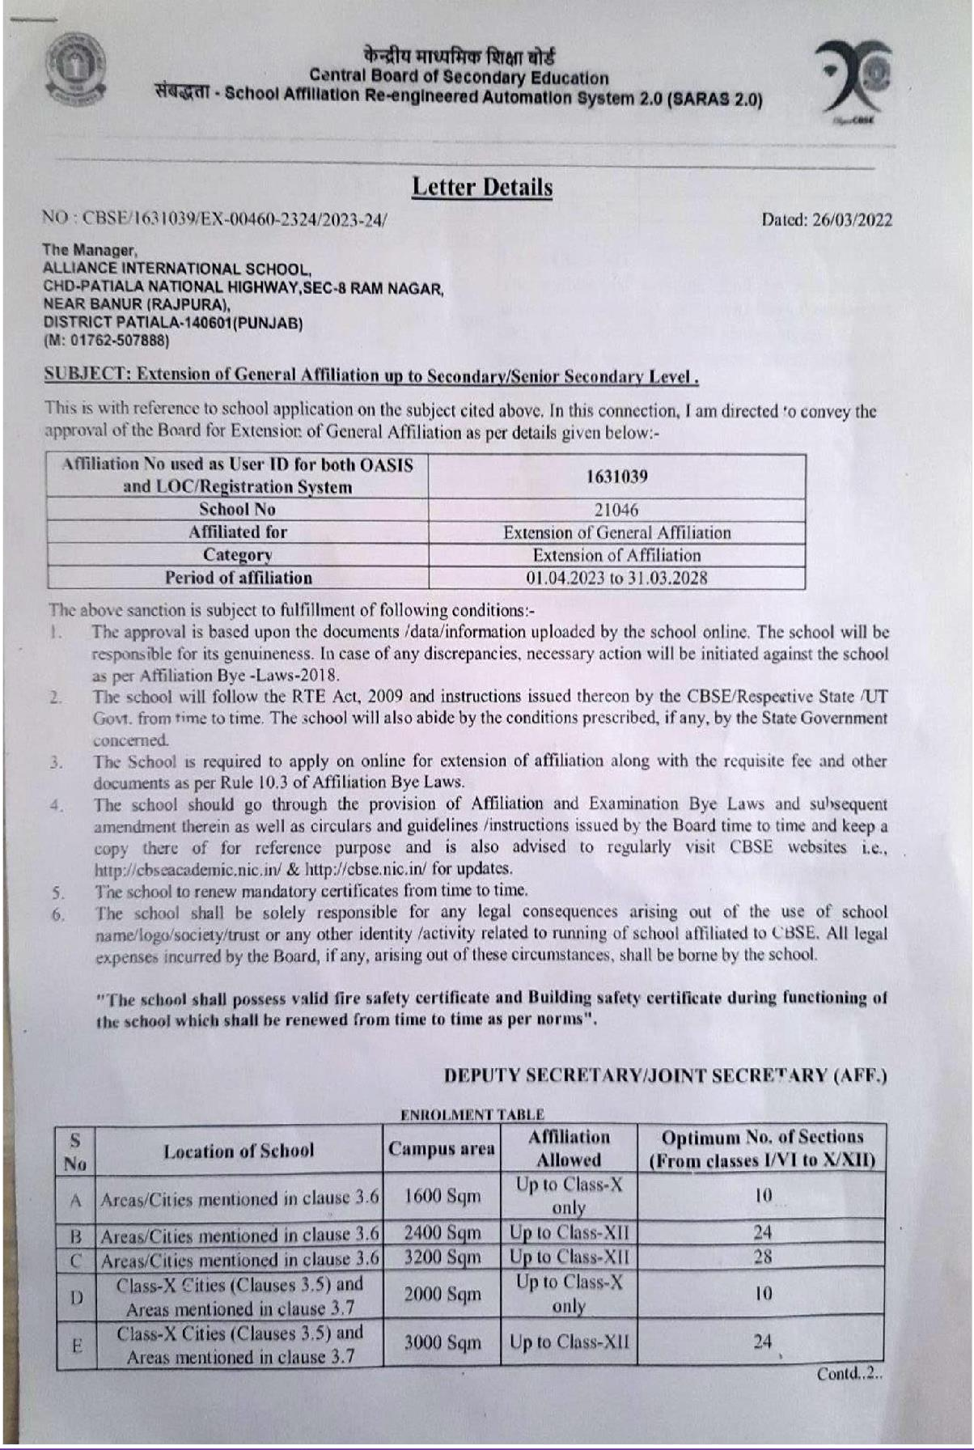

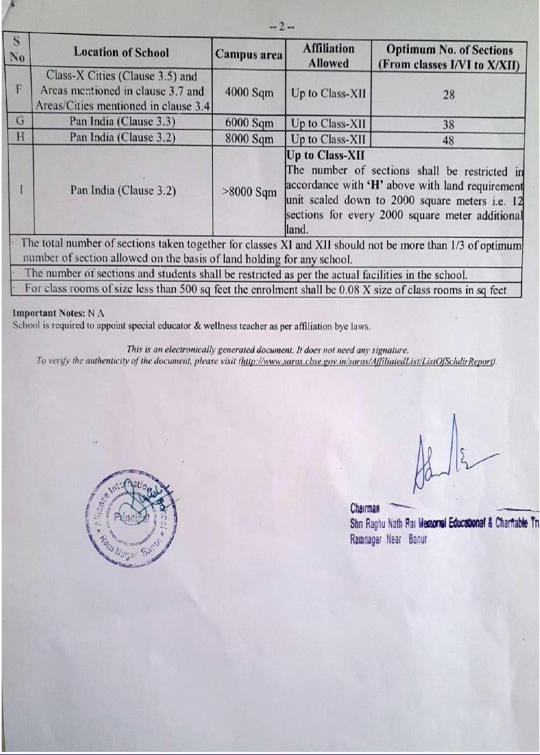

CERTIFICATE OF TRUST
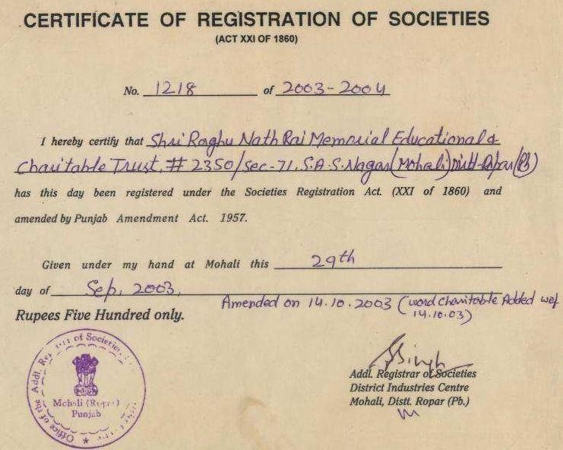

COPY OF PERMANENT RECOGNITION CERTIFICATE ISSUED BY D.E.O., SANGRUR
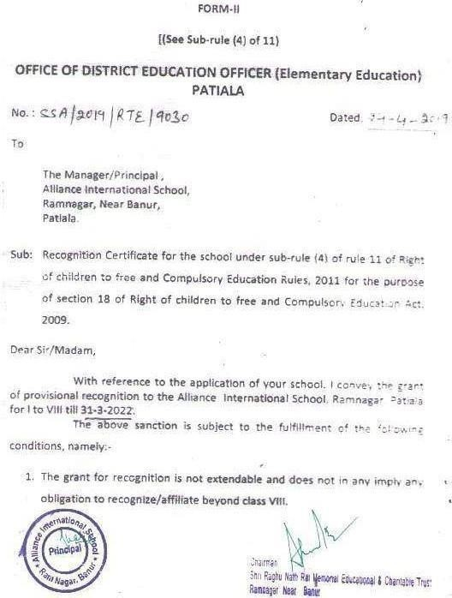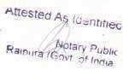

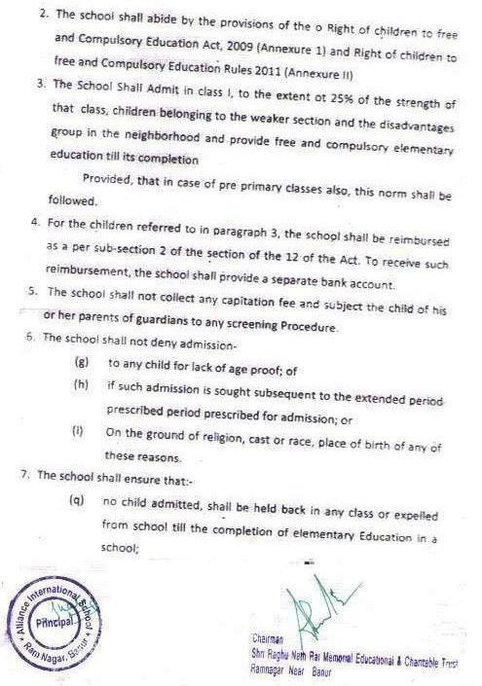

(r) no chifclshallbe subjected tophyicalou»•sment-•*-•-•ta• ha as$ment;
\s› r•ochildrequire” to.passanyboarde1a”minat›o• i nc
CGmotetiénof.etemcolaweducation:
(t)ovérvchitdcompletingelementaryeducationsnaIibeawardes?
certi*iatessTaitdownunder rule Z1;
{u)lnclusonofâYpdenfsw“rthdlabitities/spec'a!.•.•dsa‹-aprovision of act;
t4i t he 'e1'chers arprecruited withminimum gvatiF cat›onr. a? /afiunder sub-section (1) of selon 23: provided that the e”x!s*'-.t teachers who, at the time of commencement o* the Act. bo not possP.s thé minimum quaTffl tions. shall d.cQuire svch qualtfications with in the ner›od of 5 yea•’. '•crn Ehe da:ecf
$Qr•1m+nCa'mentofitheA«t,
{w) th• tea«harsperformtheirdutles,.speCif‹eduode sub•
Section{\}z›f¿4ofthgjot;and
(x)Theteachersshallnotengagehimselforherselfinanvortv3‹.e

- TABSCho”olShaft*étlowthesyllabusonthebasis.o.IcurrictJ!u Iaindamnb
ap”proprfateauthorit-y.
- Theschoolshâilenrollstudentsoroâartionate rothanormsanc•tanda•ds
aha \abIz\n the schoolasspecified›n sec‹on19 ofthe Act.
j0.Theschoolsnailmaintaint'he4y6ndardsa.ndnormsoft*”eschcoia.s

.saectfieo•»sect.on$$ofthe”Att.Thefacilities•eoorte'da.Ith4Li-er*‘azt
ctJoñ,ifmade.arease‹yen under-

Area of Schoot ca usTotalbuikupazea Atiapfplaygraund No: of ciassrooms
RaomforHeadmaster-cum-CIhcer
-cum-1toreroorñ
”Separatetoiletforboysandgi”rls
PrintingL‘VaterFacility
kitchen*ocookingMid.OayMeal
BardertreeAccess
AvaiIabiiltv'ofTeachinglearningWeterlal

›’»
Yés N.A
Yes

/PIéySports.Equipments/Library. Yes
.f4oun-reugriize.dclaS9esshall be”runwkhir the pt-m sesof theschoolsr outside of the premises in lhe same frame Ref school.
17.Theschoolbuildingsorocherstrutturgsorthegrrn.EndsshâtlbCUSA.d'D*!Y
forthe.putporeofeducationandsk›tiée•eloomen‹
13.TheschoolIsrubbyasocietyreg‹sEereduodertheSoCiettesRegistrationAct, 1B60 {Act No 31 of 1g6Ol, or a pubTi<trust conurtuted under any Jan for the”t‹me bef•g ›n force.
1A,TheSchoolisnorrunforprofittoanyindividual, gicupo•a'sSoc-3t•ono•
individualsorandectier.pwsén.

t5. Th« accounts Should be audited and certified by a Charteieb Accc••:an: and proper accounts Statements Cha Id be p gpgred âs per w‹es. .*cw eachoftheswtcmcntsoféccauntlshouldbe”senttgth=.D1t*itrt tdur.a,@r•



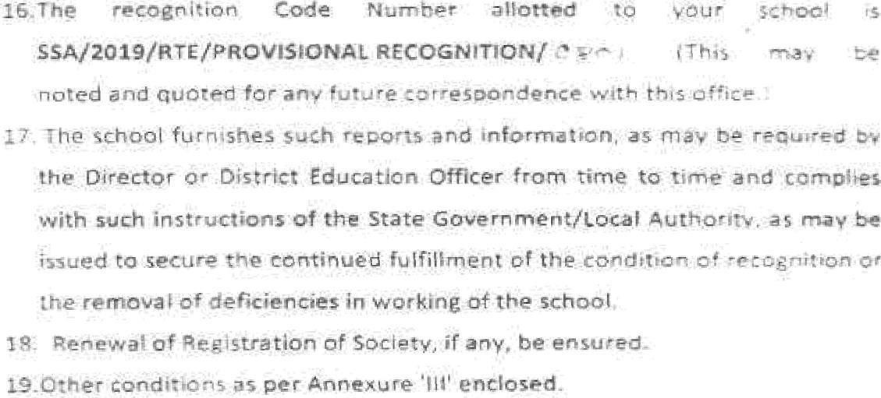

Dturict”Edizcât‹on”'DaftarfEfamentaryE..iu<atJon}







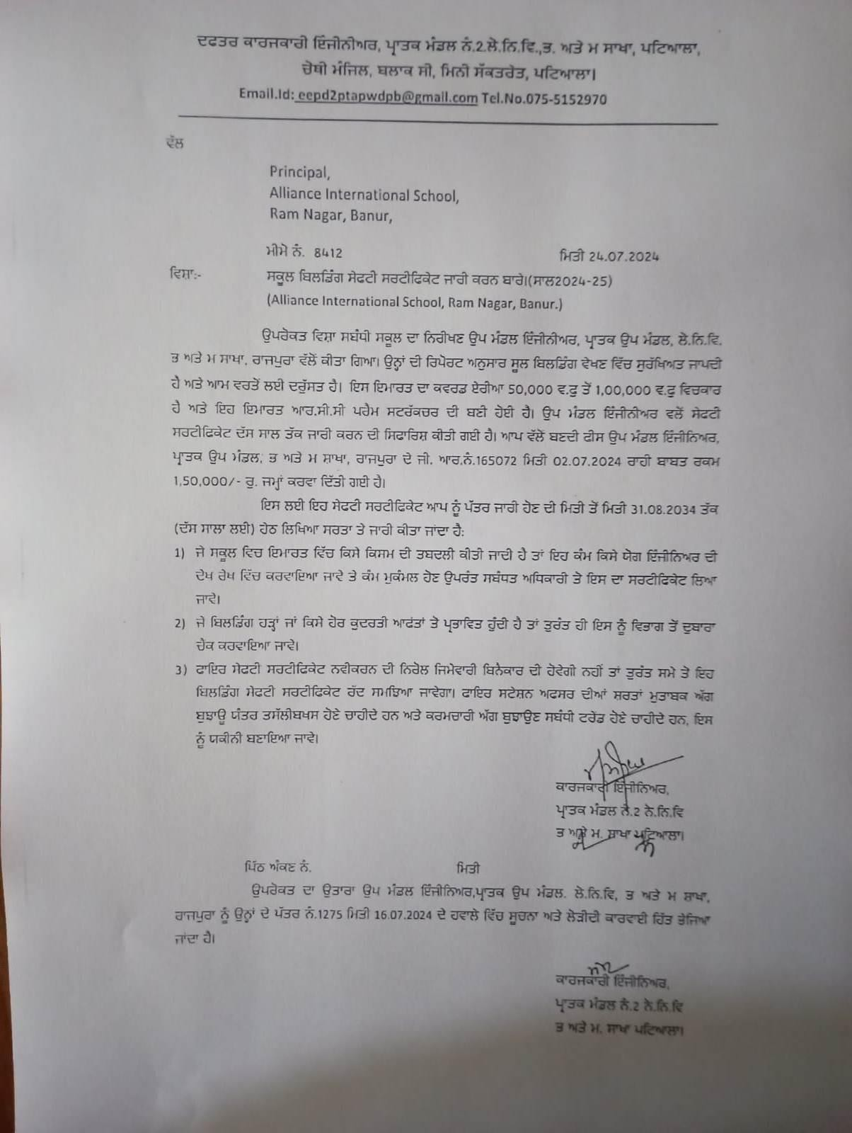

COPY OF WATER, HEALTH ANDS SANITATION CERTIFICATE

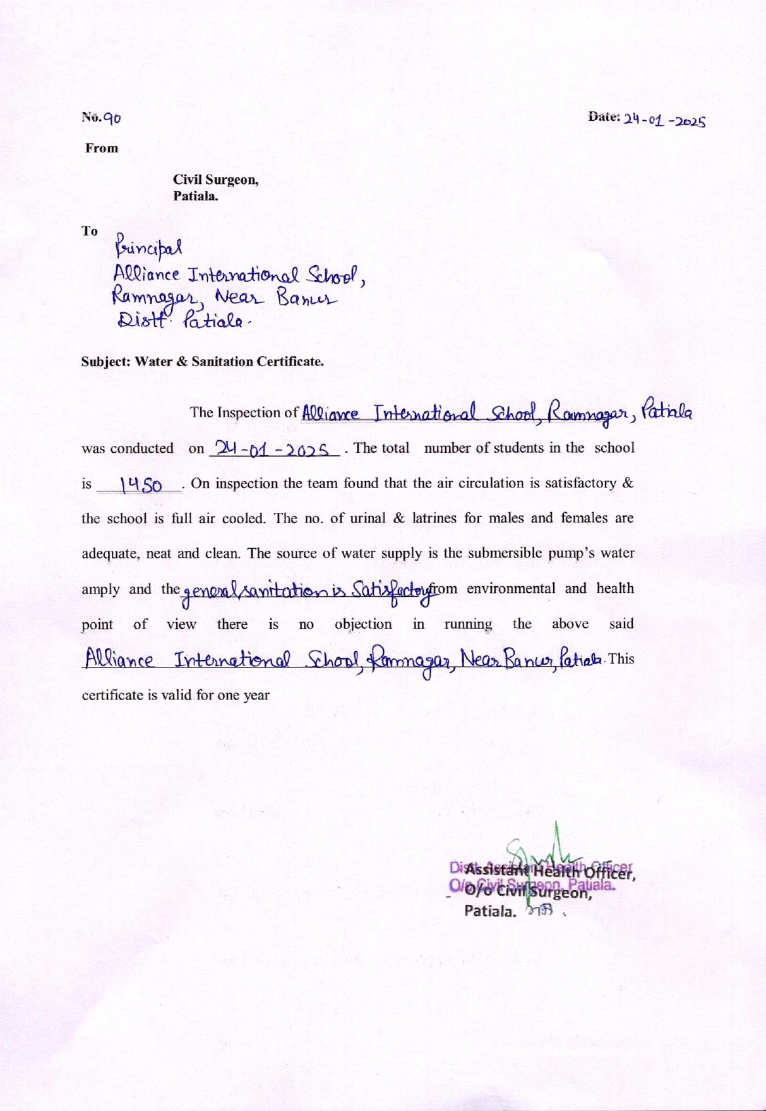

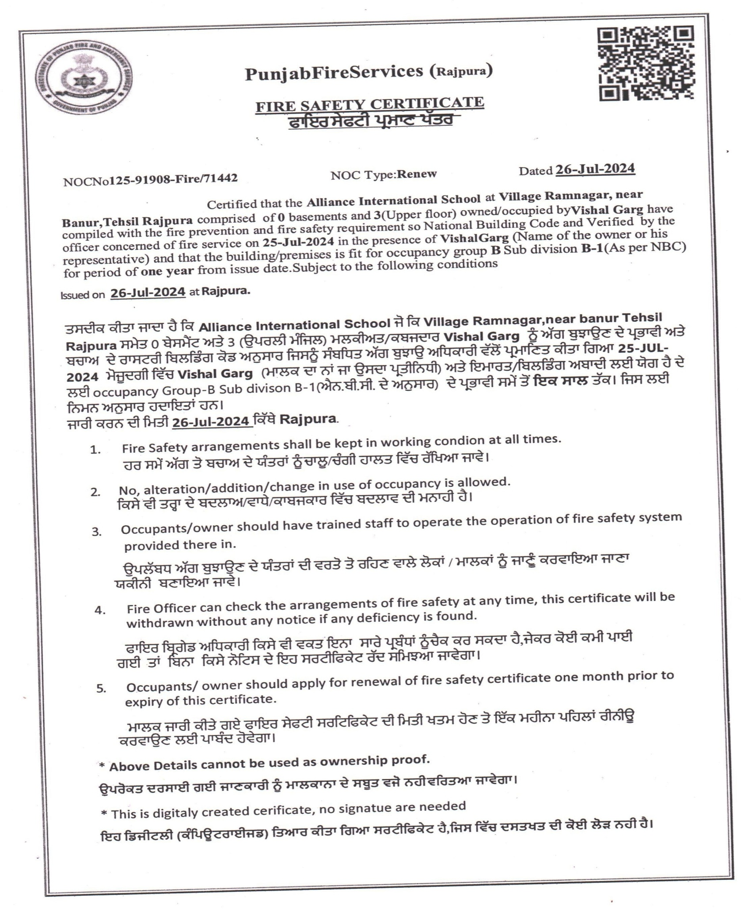


Fee Structure for session 2025-26
Category | Classes | Fee Amount
Registration Fee | All | 999 (one time)
Admission Fee | Kindergarten | 18000 (one time)
Admission Fee | I to IX, XI | 20000 (one time)
Annual Charges | All (student September 2021 onwards) | 6000(per annum)
Tuition Fee | Pre-Nursery to KG | 3360 (per month)
Tuition Fee | I to V | 3900 (per month)
Tuition Fee | VI to X | 3990 (per month)
Tuition Fee | XI & XII - Humanities | 4135 (per month)
Tuition Fee | XI & XII - Commerce | 4210 (per month)
Tuition Fee | XI & XII - Science | 4330 (per month)
Sports Academy (optional) | VI to XII | 1200 (per month)

ACADEMICCALANDER2025-26
S.  No. | Date | Celebration | Competitiontobeheld
 |  | Celebration | Group A  VIII-X | Group B  V-VIII | GroupC  I-IV | Nry-UKG | Club
1 | 1April,25 | NewSessionBegins
2 | 6April,25 |  | BagPacking | BagPacking | BagPacking | BagPacking | Art&CraftClub
3 | 7  April,25 | Health Day | HealthyTiffin | HealthyTiffin | HealthyTiffin | HealthyTiffin | HealthClub
4 | 12  April,25 | Baisakhi | Turbantying | PunjabiFolk Dress | PunjabiFolk Dress | PunjabiFolk Dress
5 | 21  April,25 | EarthDay | PosterMaking | ChartMaking | ChartMaking | Draw Earth | Gardening Club
6 | 23April,25 | Book Day | ReadingContest | ReadingContest | ReadingContest | ReadingContest
7 | 8 May,25 | Mother'sDay | CardMaking | CardMaking | CardMaking | CardMaking
8 |  | Periodic1Testfrom22ndMay,2025
9 | 3June,25 | PTM
10 |  | SummerVacationfrom1June,25
11 | 2July,25 | SchoolRe-open
12 | 21  July,25 |  | Calligraphy English | Calligraphy English | Calligraphy English | Vegetable Printing | Language Club
13 | 30  July,25 |  | BoysHandball | GirlsKho-Kho | 100mRace | Hop Race | Maths Club
 | 8  Aug,25 |  | Declamation | RakhiMaking | RakhiMaking | RakhiMaking | Art&Craft Club
14 | 14  Aug,25 | Janmashtmi Celebration
16 | 15Aug,25 | Independence Day
17 |  | HalfYearlyExamfrom11September,25
18 |  | PTMon25September,25
19 | 1Oct,25 | DussehraCelebration
20 | 15Oct,25 |  | ScienceQuiz | ScienceQuiz | ScienceQuiz | StoryTelling | ScienceClub
21 | 18  October,  25 | DiwaliCelebration | RangoliMaking | Diyas Decoration | Candle Decoration | DrawDiyas | Art&Craft Club
22 | 29  Nov,25 | PoemRecitation | Poem Recitation | PoemRecitation | Poem Recitation | Poem Recitation | GKClub
23 |  | Periodic2Testfrom11thDecember,2025
24 | 24  Dec,25 | Christmas Celebration | Tree Decoration | Play | DrawSanta | DrawSanta | Art&Craft Club
25 |  | WinterVacationfrom25Decemberto5December
26 | 12Jan,26 | LohriCelebration
27 | 24  Jan,26 | Republic Celebration | Debate | Debate | Learn Pleamble | ColorsFlag | Maths Club
28 |  | AnnualExaminationFrom1March,2026


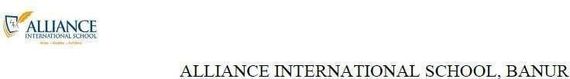

LIST OF RE-CINSTITUTED MANAGING COMMITTEE Of
ALLIANCEINTERNATIONALSCHOOL
Chd-PatialaHighway,Sec-8,RamnagarBanur,Patiala140601

S. No | Member Name(Mr./ Mrs./Ms.) | Father's/Husband Nam (Shri) | Designation | Occupation | Residential Address | Contact No.
1 | Ashwani Garg | Late Raghu Nath Rai Garg | Chairman | Businessman | G02,Tower A2, World OneSociety,Sec-115, Sante Majra, Mohali | 9876463000
2 | Ankur Gupta | S/o Kanhaiya Lal Garg | Executive Member | Director Corporate Affairs | C23, Rajpura Colony,Near Vir Haqikat Rai Shool, Patiala | 7837300499
3 | Arun Kumar | S/o Late Vinod Kumar Goyal | Executive Member | Private Service | 2092,Sector-52, Chandigarh | 7837300469
4 | Davinder Kaur | W/o Amarjeet Singh | Teacher | Teacher, Allinace  International School | H.no.2,Navyugcolony, Back Side Mittal hospital, Rajpura | 9914898159
5 | Jyoti | D/o Hari Krishan | Teacher | Teacher, Allinace International School | #2895,NearPanjiri Plant, Rajpura | 7814509400
6 | Harpreet Kaur | D/o Gurchaan Singh | Parent | Parent, Alliance International School | C4-102,RailVihar,VIP Road,Zirakpur-140603, | 8264406690
7 | Ruchika Sharma | W/o Krishan kant Sharma | Parent | Parent, Alliance International School | #1/225,SheetalColony, Rajpura | 9888020055
8 | Dr.Pretik Garg | S/o Ram Kumar | Principal | Educationist | #2352/1,OldLalBagh, Patiala | 8847224530
9 | Pankaj Sharma | S/o Om Parkash | Principal | Educationist | #135,ShalimarGarden, Rama Mandi,Jalandhar | 9888750970

LIST OF RE-CONSTITUTED PARENT TEACHER ASSOCIATION OF

To bring home and the school in close contact and to promote the welfare of the students in home and in community. If both of them i.e. Teachers as well as parents, come forward together, know each-other, understand each-other, it helps in growth and development of student’s progress.

S.No. | MemberName | Designation
1 | Brijesh Saxena | Secretary (Principal)
2 | Tamanpreet Kaur | Member (Teacher)
3 | Reema Kundalia | Member (Teacher)
4 | Harpreet Kaur | Member (Parent)
5 | Ruchika Sharma | Member (Parent)

COPYOF ECS CERTIFICATE ISSUEDBYBANKMANAGER
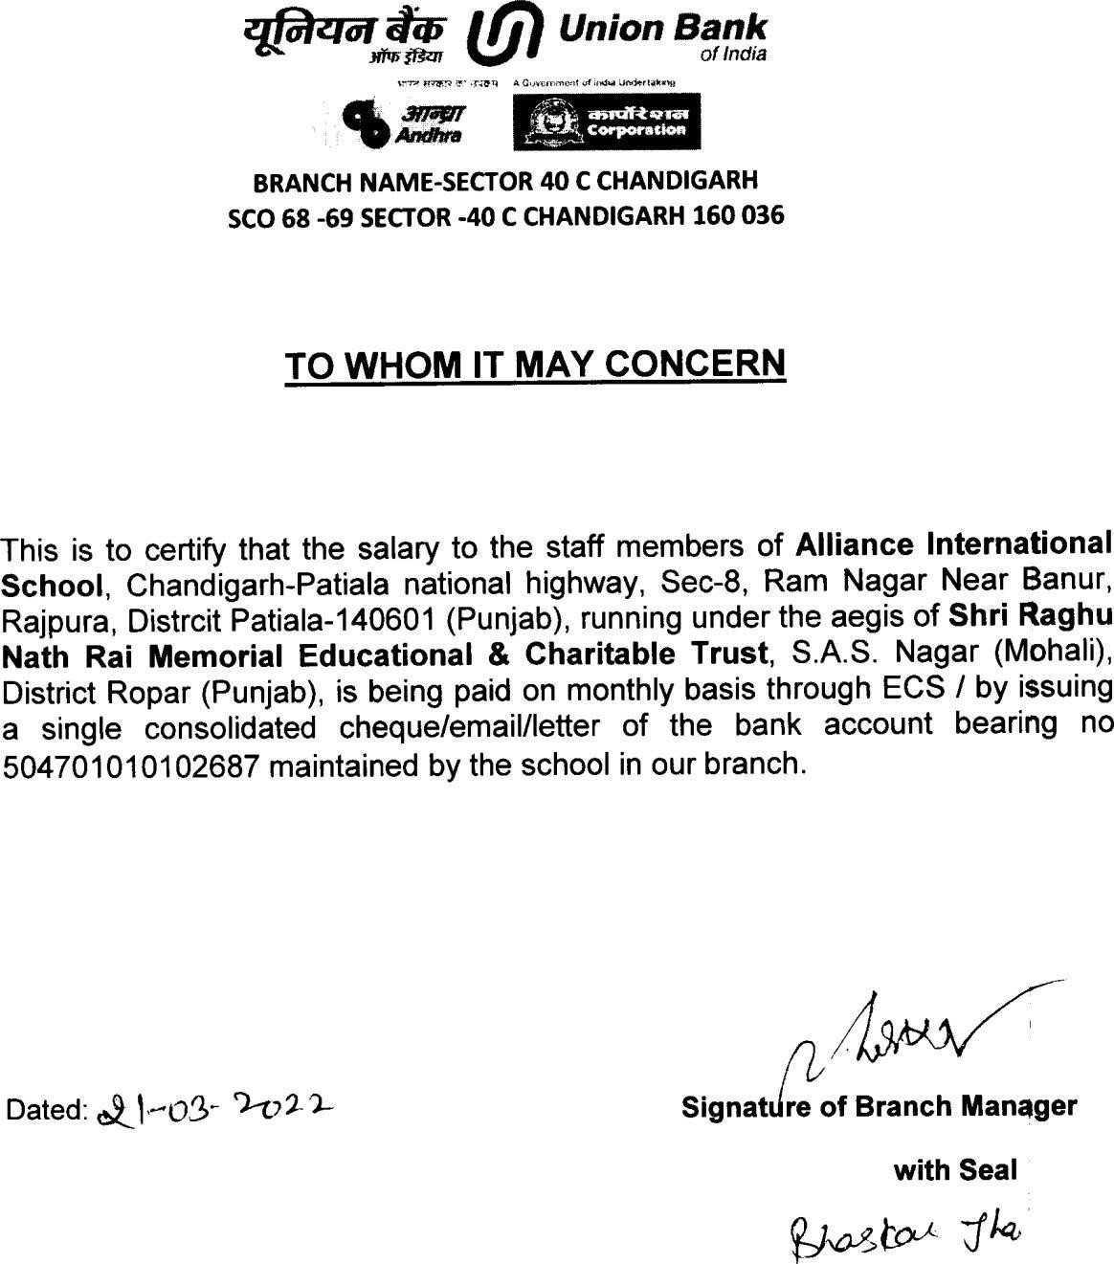

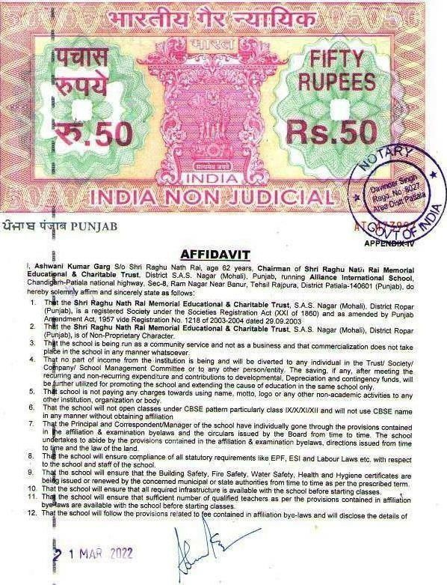COPYOFAFFIDAVITASPERCBSENORMS

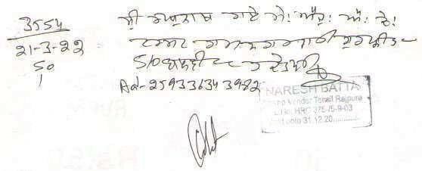

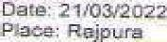











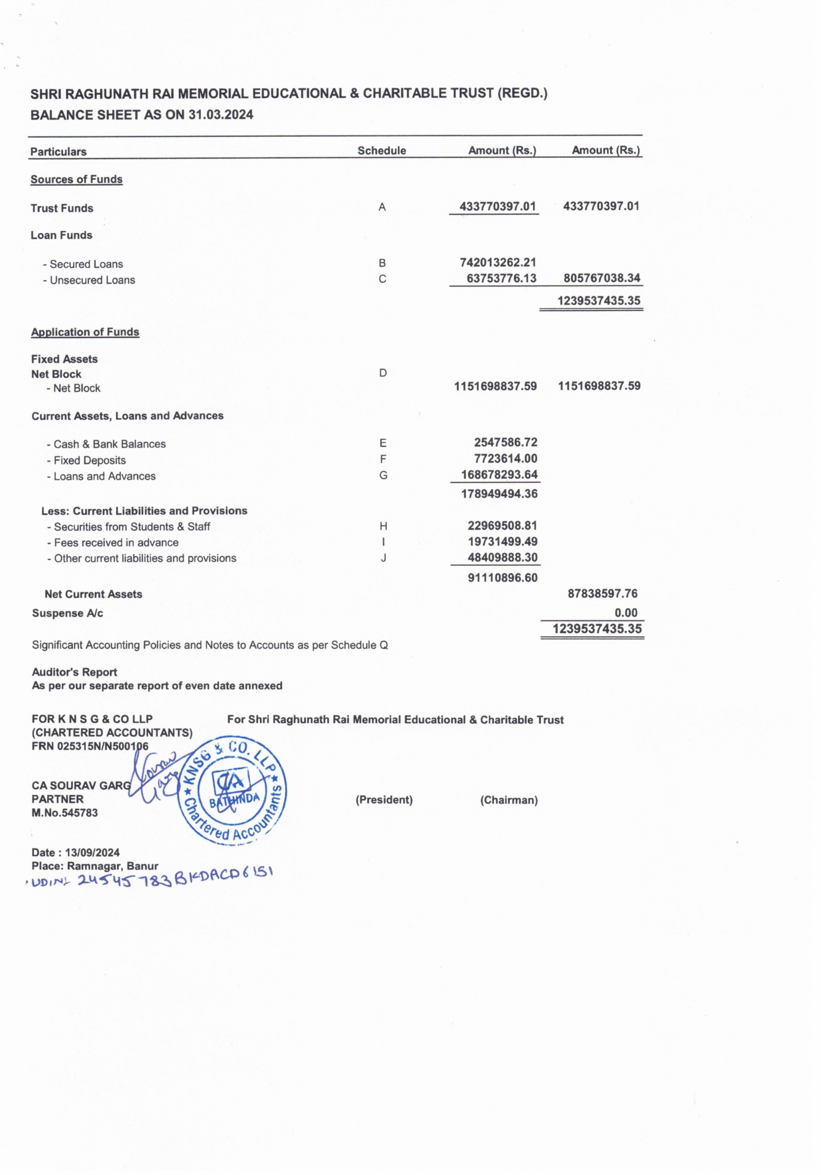
COPY OF BALANCE SHEET DULY AUDITED BY CHARTERED ACCOUNT

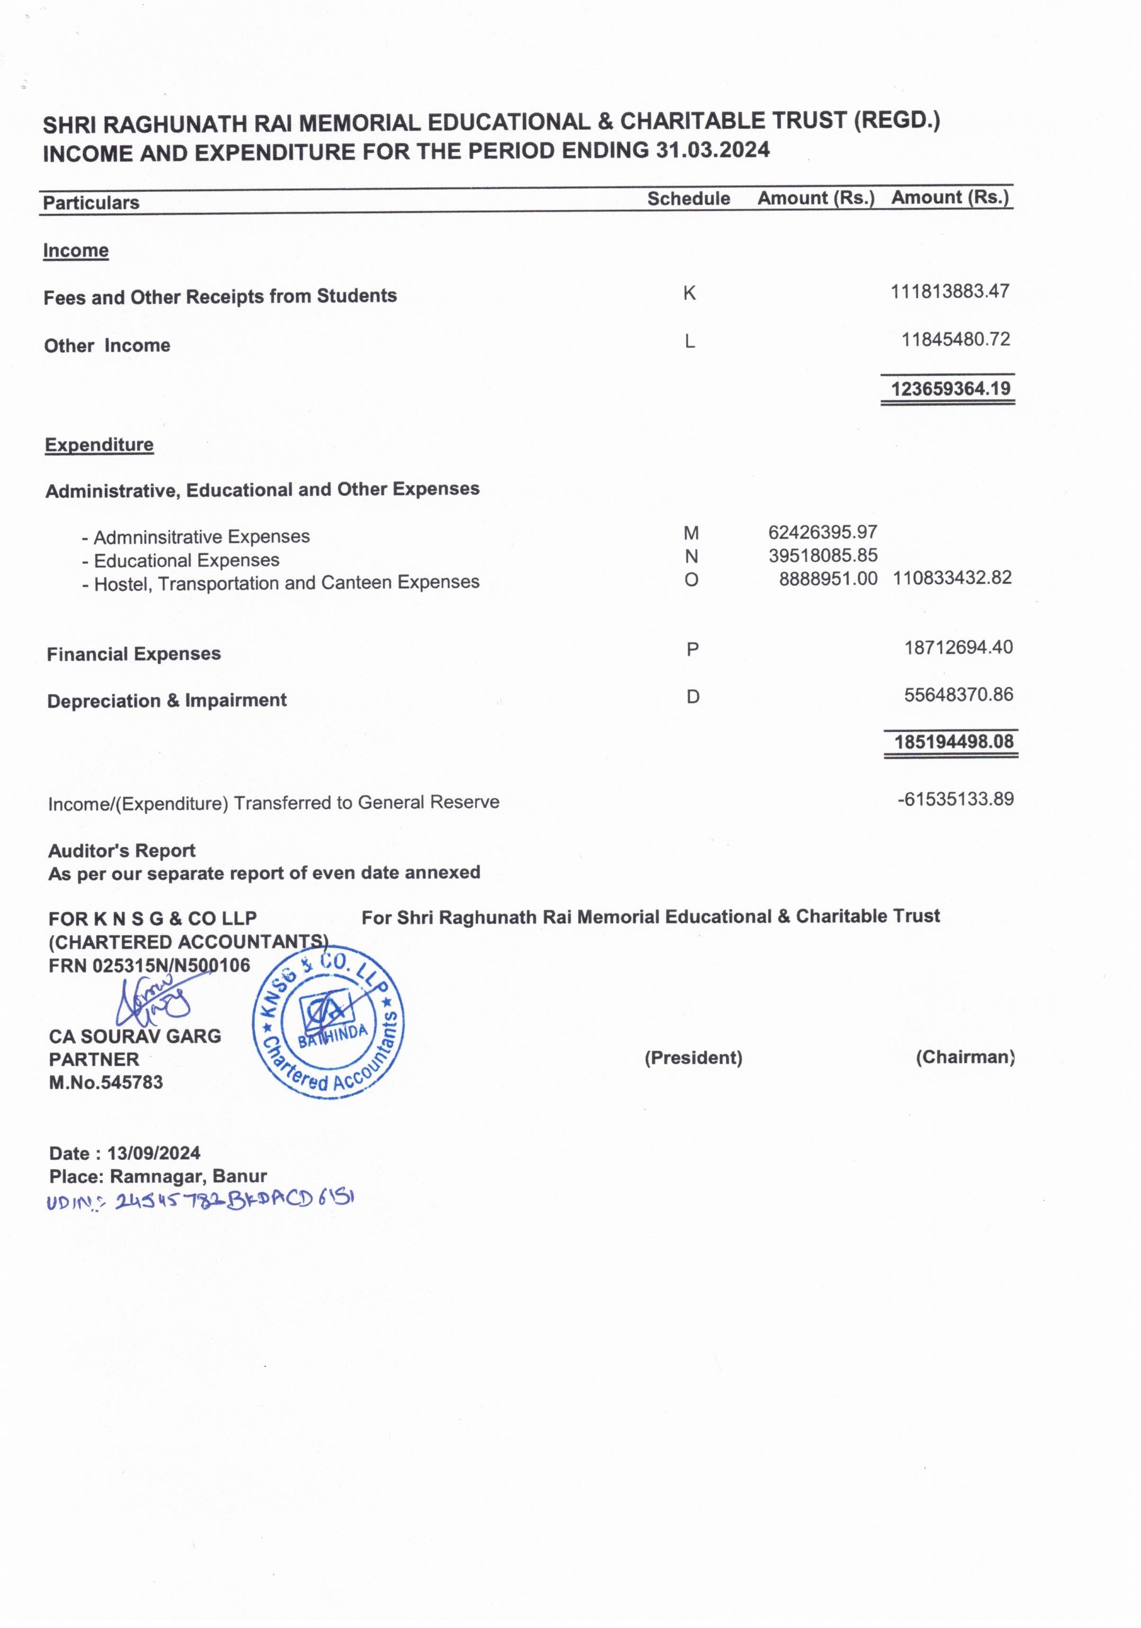
Dated:1stApril,2024

TOWHOMITMAYCENCERN

This is to certify that as per CBSE guidelines and to get rid of heavy satchel for little tiny tots, school strictly implements 'No Homework Policy' for the students from class I and II and further wish to state that the same has stated on official website of the school.

DETAILS OF NORMS FOLLOWED FOR FIXING THE SCHOOL FEE
Copy of Proceedings of the meeting of Shri Raghu Nath Rai Memorial Educational & Charitable Trust, S.A.S. Nagar(Mohali), District Ropar (Punjab)
RESOLUTION NO.:2024/# VENUE: S.A.S. Nagar (Mohali)
DATE:19.03.2024 TIME:10.30AM

All the Member (s) of the Society are present.
Agenda –Enhancement/ fixation of Fee & Funds of Alliance International School, Chandigarh-Patiala national highway, Sec-8, Ram Nagar Near Banur, Rajpura, Distrcit Patiala-140601 (Punjab), running under the aegis of running under the aegis of Shri Raghu Nath Rai Memorial Educational & Charitable Trust, S.A.S. Nagar (Mohali), District Ropar (Punjab), for the coming academic session 2021-22, after consulting the members of PTA and keeping in view the provisions of Section 5 of the Punjab Regulation of Unaided Educational Institutions Bill (Punjab Act No.47of 2016).
Chairman & Business: A meeting is held under the chairman ship of Sh. Ashwani Kumar Garg,to discussand finalize enhancement/ fixation of Fee & Annual Funds of Alliance International School,Chandigarh-Patiala national highway,Sec-8,Ram Nagar Near Banur, Rajpura,Distrcit Patiala-140601 (Punjab), for the academic session 2021- 22,after consulting the members of PTA and keeping in view the provisions of Section 5 of the Punjab Regulation of Unaided Educational Institutions Bill (Punjab Act No.47of 2016).
Conclusion–
After detailed discussions on the Agenda in the meeting, it is unanimously passed in the meeting to enhance/fix Fee & Annual Funds of Alliance International School, Chandigarh-Patiala national highway, Sec-8, Ram Nagar Near Banur, Rajpura, Distrcit Patiala-140601 (Punjab), for the academic session 2021-22 as it is as of academic session 2020-21 and by following the provisions of Section 5 of the Punjab Regulation of Unaided Educational Institutions Bill (Punjab Act No.47of 2016).
Further, it is also unanimously passed in the meeting that the requirements of the allocated budgeted funds discussed in the earlier meeting, would be met from the funds to be generated from the Tuition Fee and Annual/ other Funds generated from the beginning of the academic session 2021-22.
Confirmation–The members present in the meeting appreciated the growth of the school & have given their consent by putting their signatures in confirmation of today’s business.
Vote of Thanks–The meeting is adjourned with a vote of thanks.
CERTIFIEDTRUECOPY

